1. Create awsusers ec2admin1,ec2admin2,ec2admin3 with ec2full admin access with only console login privilege. Create group with appropriate name if required.

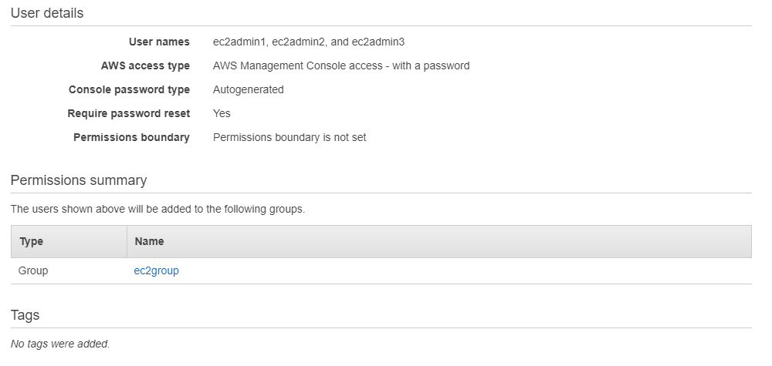

1. Create awsusers s3admin1,s3admin2,s3admin3 with s3fulladmin access with both console and programmatic access. Create group with appropriate name if required.

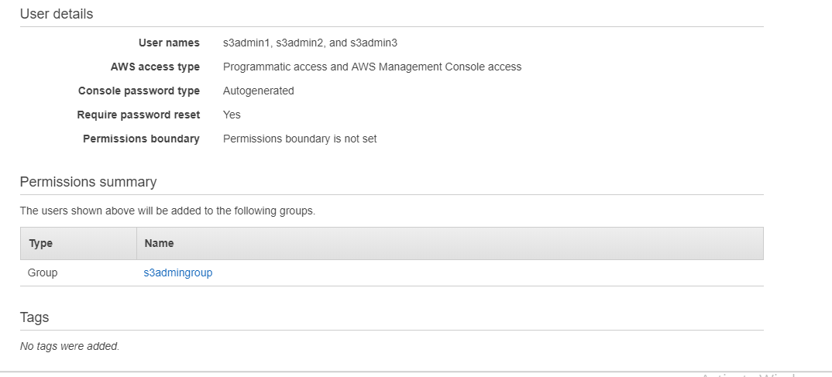

1. Create awsuser l3admin with full access and should have both console and api login.

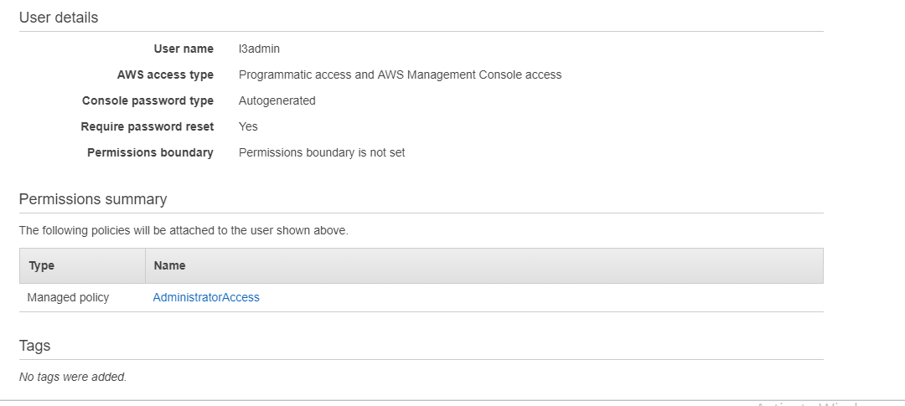

1. Create new role ec2s3role with s3 full access. We will use this role in later exercises.

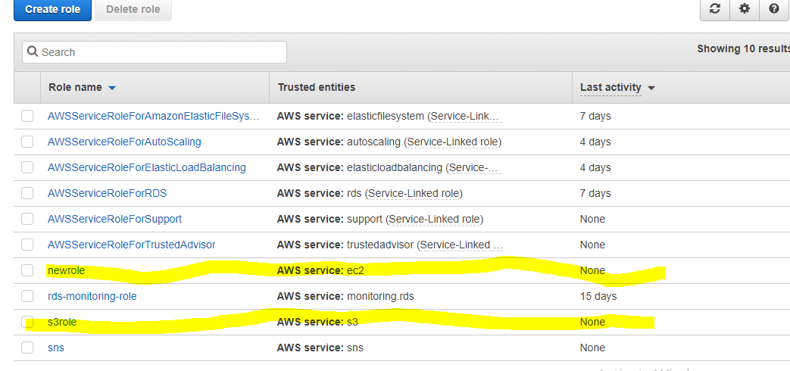

2@ .Create new VPC labvpc which should have internet connectivity. use appropriate gateway. Use any region you wish which satisfy below requirements

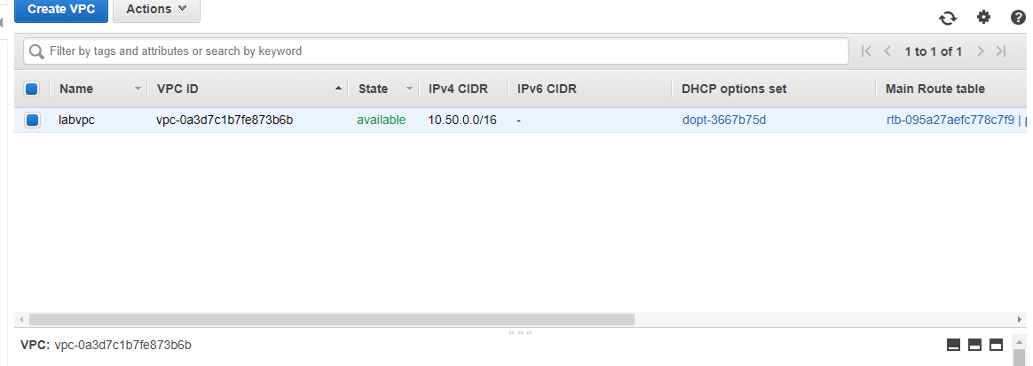

Create 4 subnets as below. Public subnets should have internet access. private servers should have only outbound only internet access.  
PublicSubnet1 AZ-a  
 PublicSubnet2 AZ-b  
 PrivateSubnet1 AZ-a  
 PrivateSubnet2 AZ-b

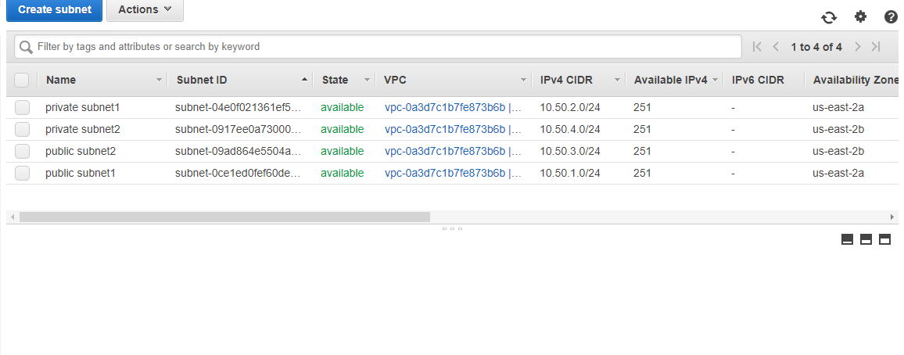

@* Create EC2 windows server which should have login from internet. Use any public subnet. Attach 1GB disk to the windows server and mount it as H: drive

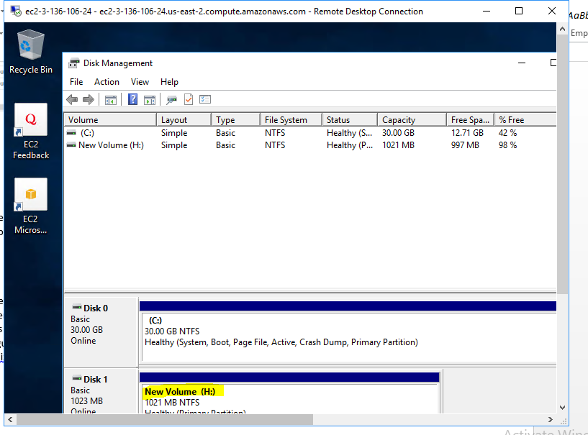

@ *Create one Public Ec2 instance webserver and one private db Server.

(createdlinux server )

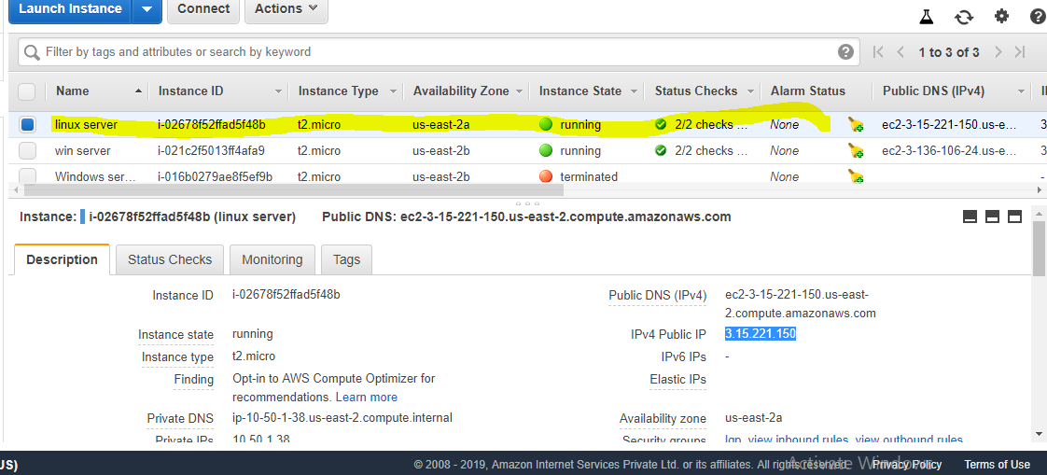

Follow steps in the attachment webserver and db connectivity exercise.txt notepad for further.

(configurelinux webserver in private)

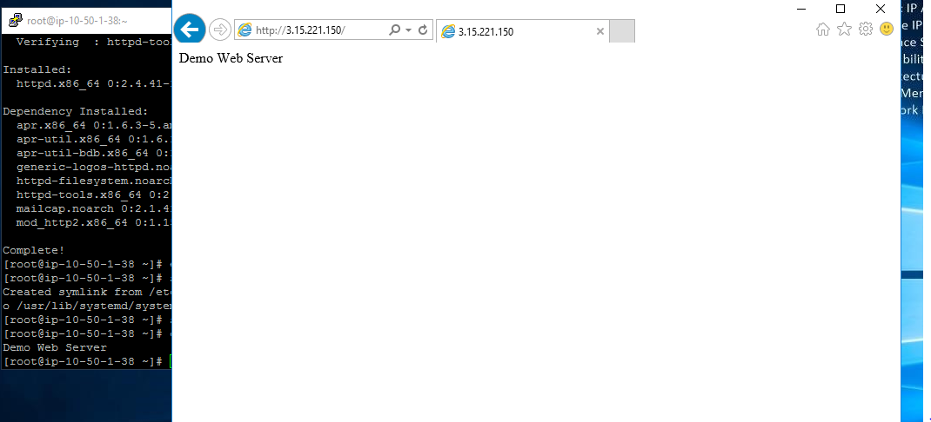

Assign s3role created in exercise 1 to access s3 buckets  
configuration.  
All Unix servers should have 1GB ebs attached and mounted as /data.

(in linux server added volume and mounted the volume )

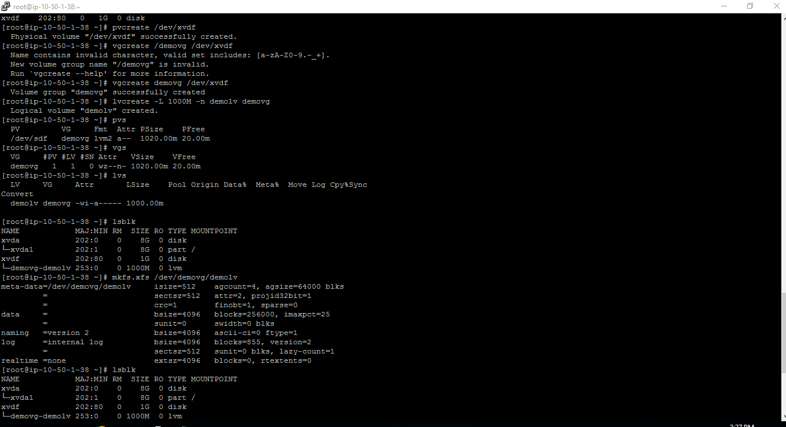

@ *Create s3 bucket namde labcasestudy2019 and upload some demo data.

(s3 bucket is created , and added some data to access the public site to download)

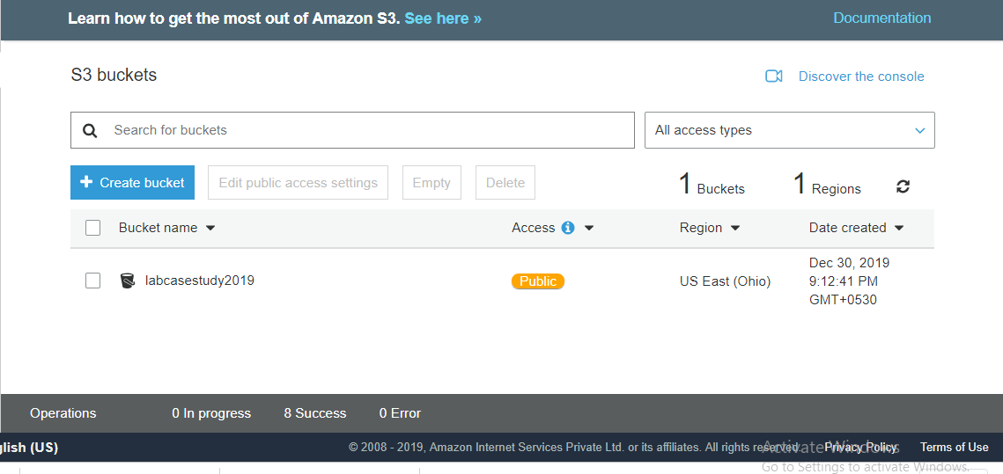

We can able to access for single file in public through s3 url

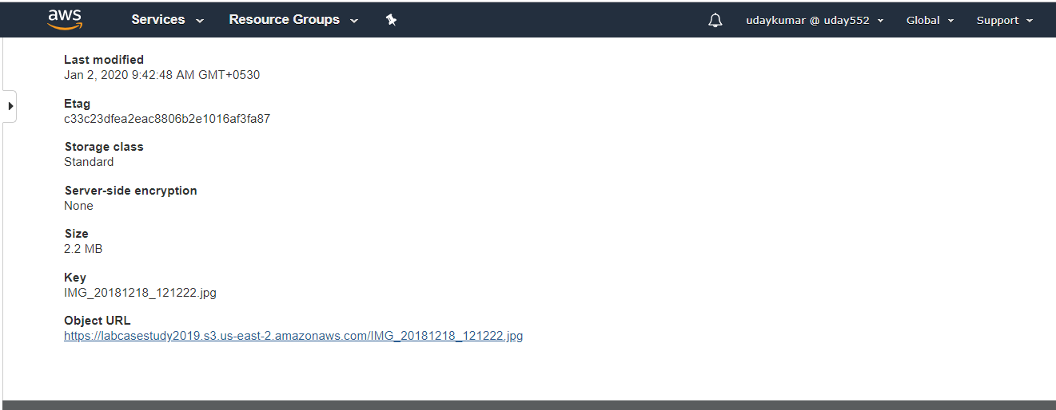

Sample url result

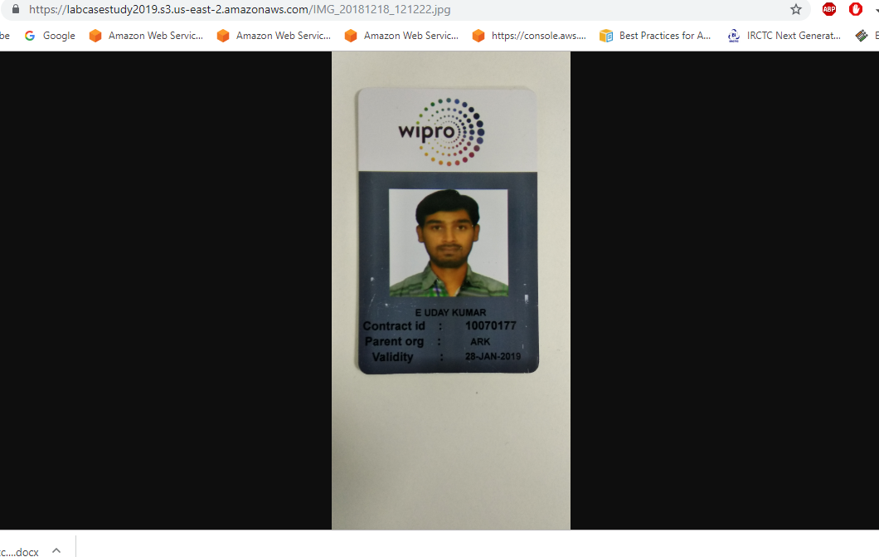

Configure static website hosting using the previously shared files.

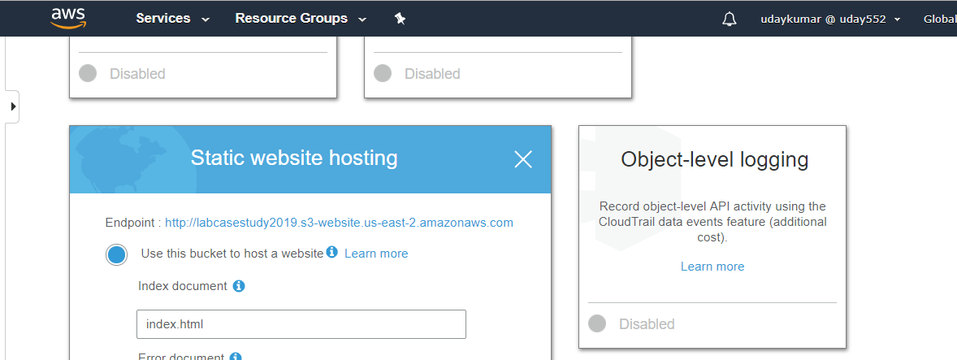

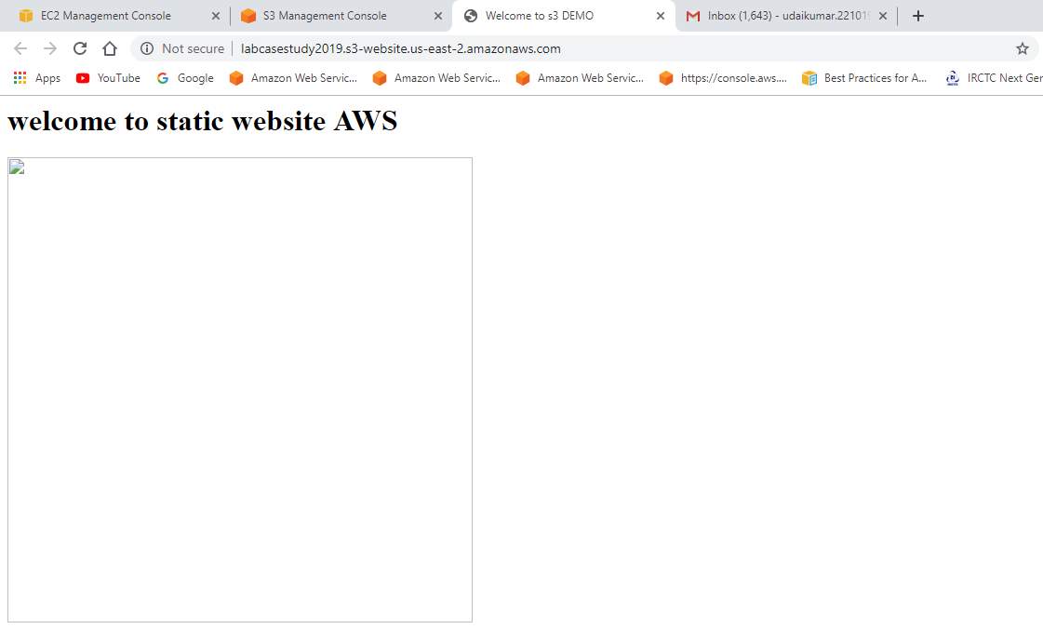

(I created static website and s3 only files can able to sharing ,I am unable to sharing folder)

@ * Create efs file share and mount it as /efs in all the linux servers

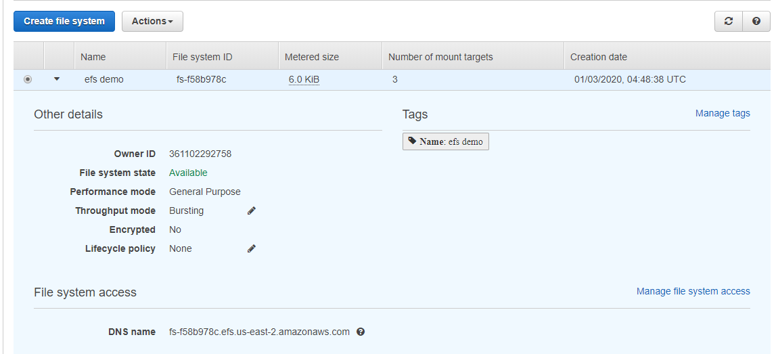

(EFS is created sample program configure result in below snapshot)

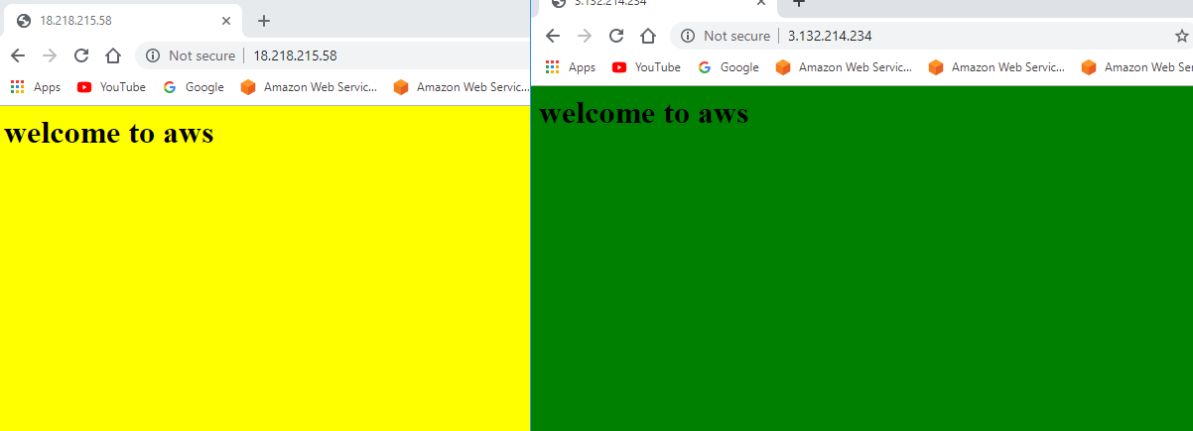

@ * Configure Elastic Load balancer using 3 instances. Use ASG to create instances [ Refer ELB+ASG document]

Created loadbalancer

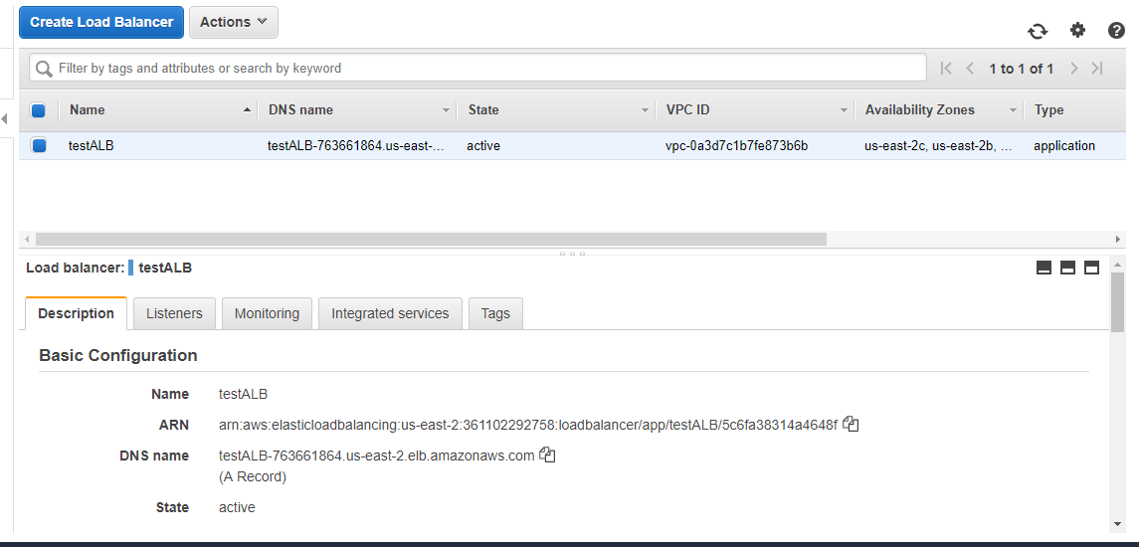

Created auto scaling

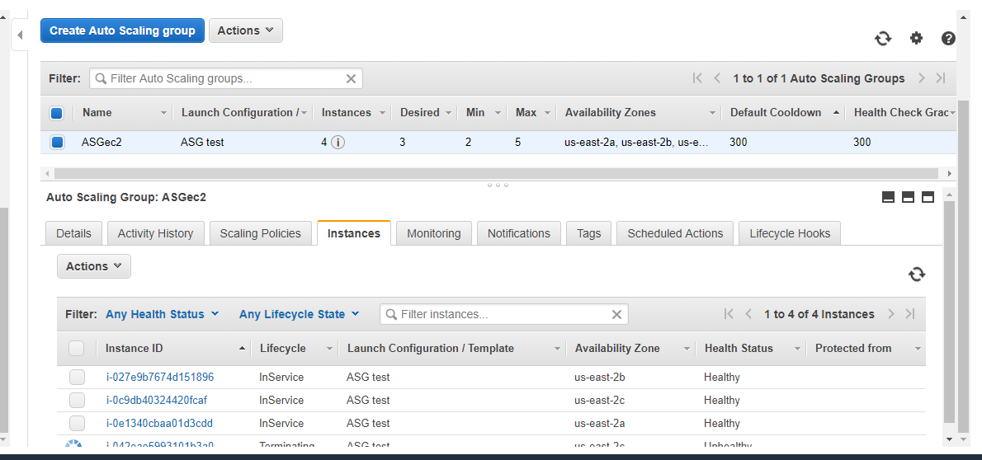

Auto scale policy

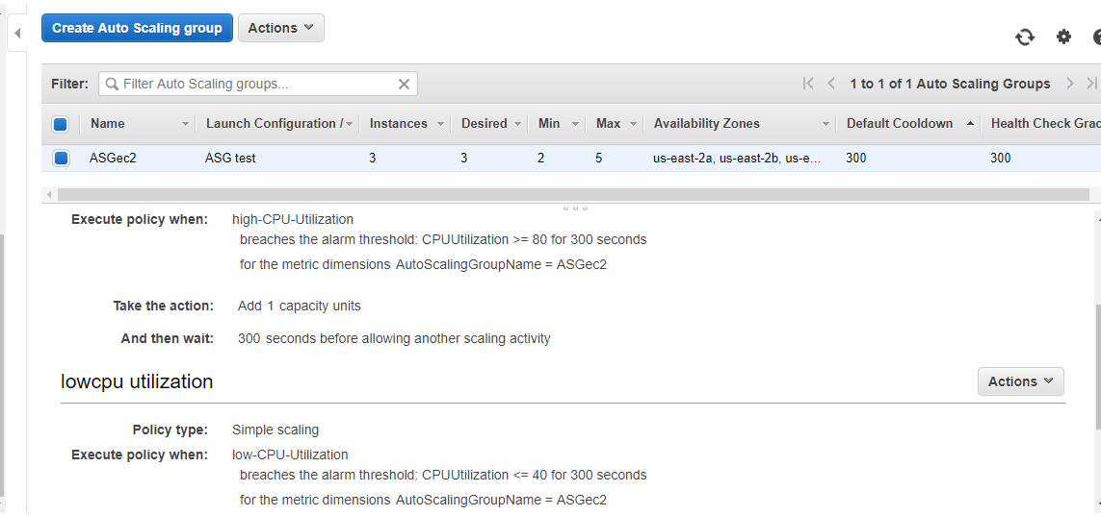

Login to instance install the package stress and run the cmd “stress –cpu 2 –timeout 90000”

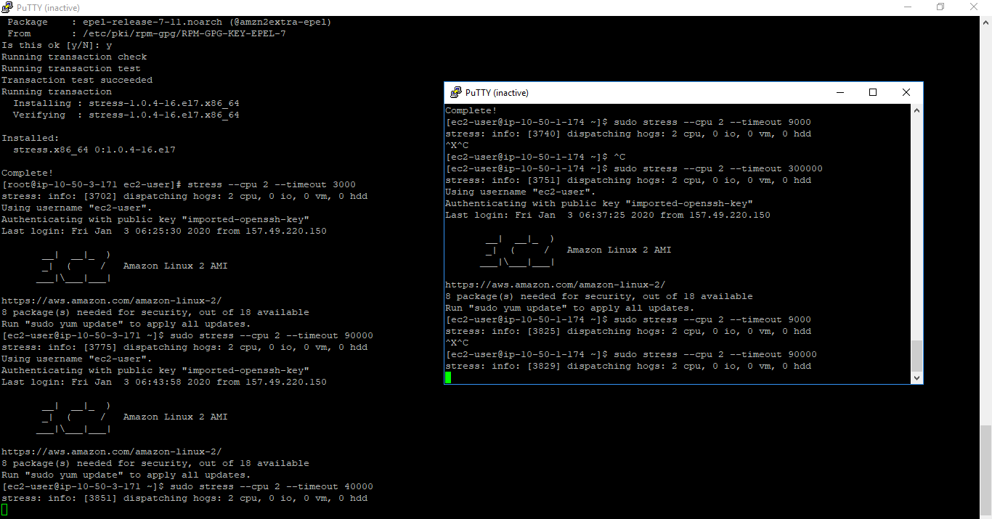

Automatically launch the one more instance

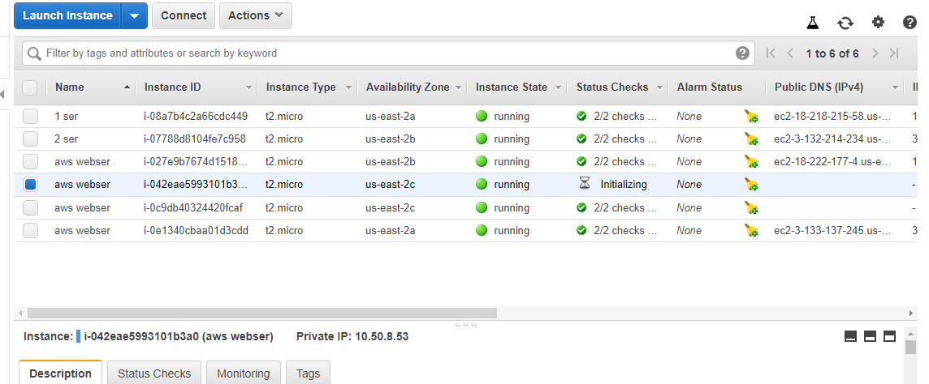

Create scaling policies for the above ASG and ensure scale up happens when cpu crosses 80% and scaledown happens at 40%

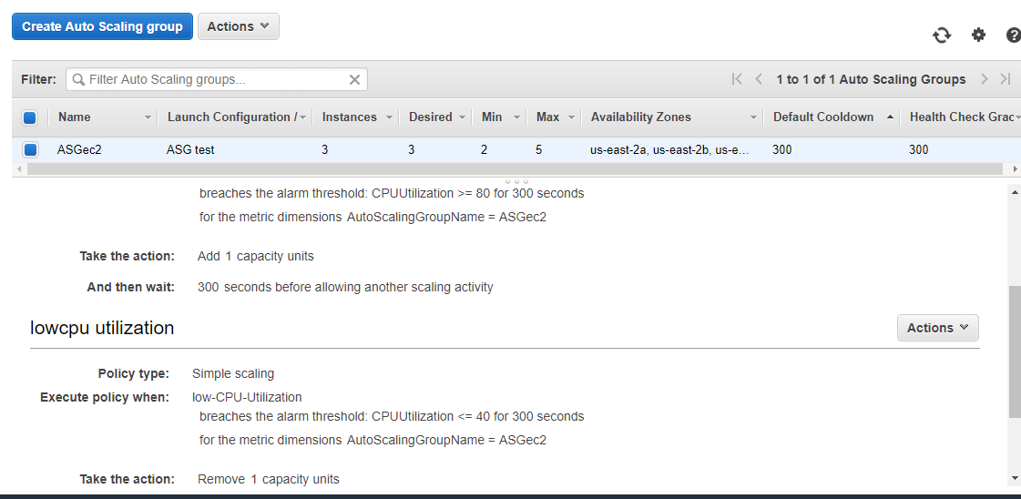

|  |
| --- |
| * Route 53 [Optional] Use above created static s3 website and elb to create custom route 53 website address |
| Create AMI of the webserver created in step 2 and copy it to another region. Launch and very functionality |

(created instance in north varzinia )

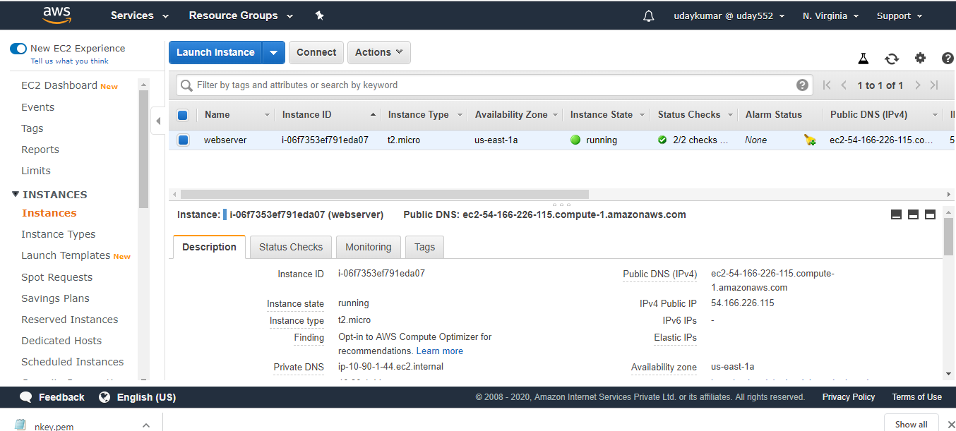

( created webserver in north varzinia )

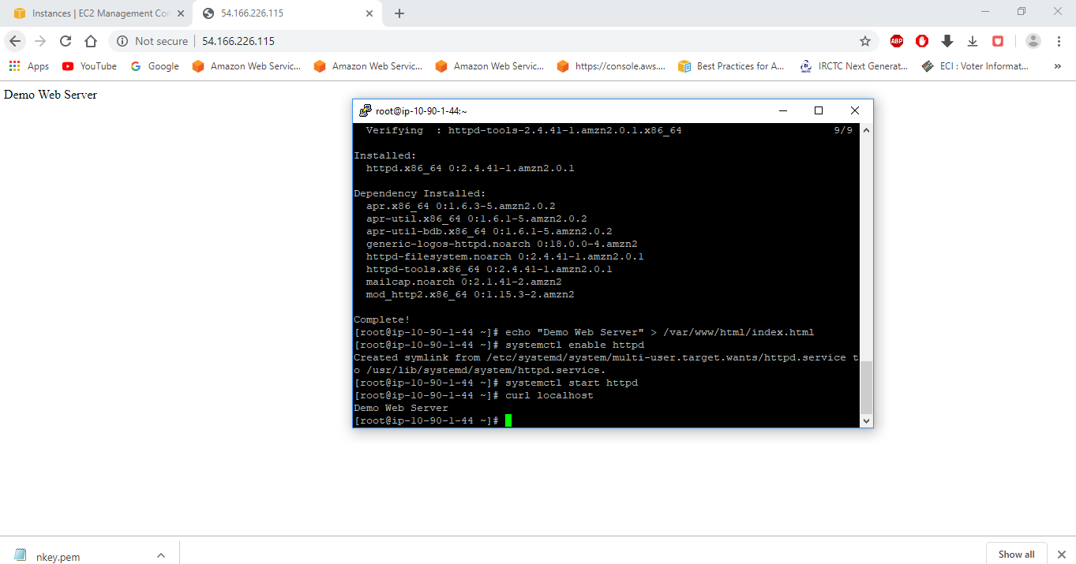

Snapshot copied to ohio region

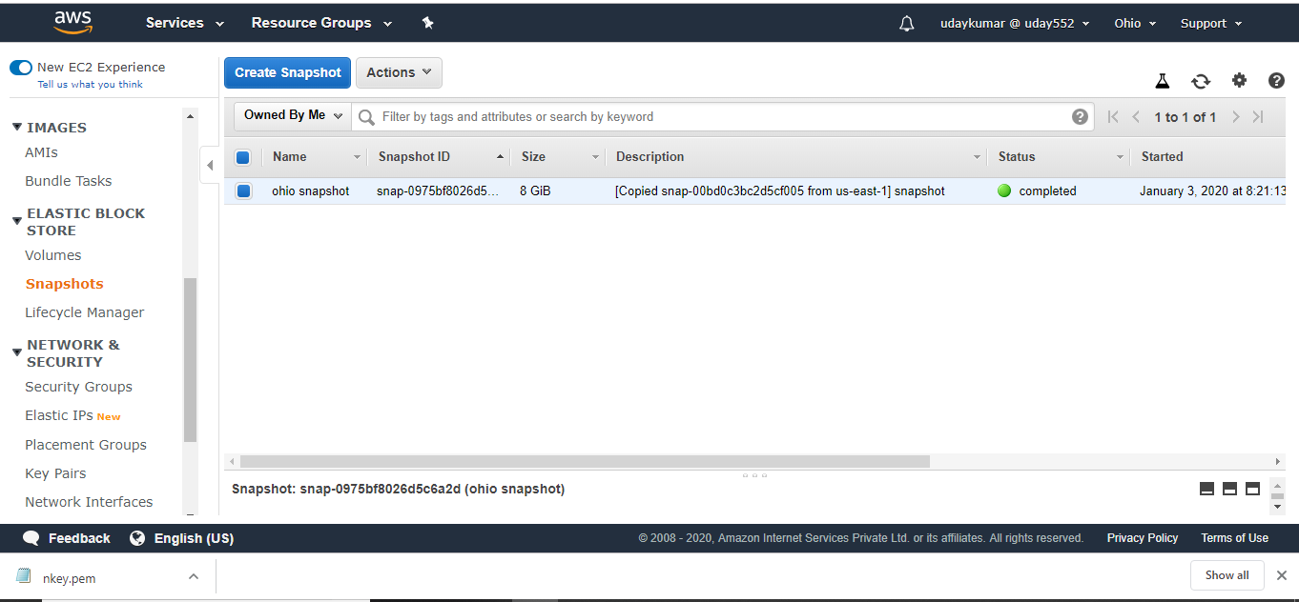

Created image inthis snapshot

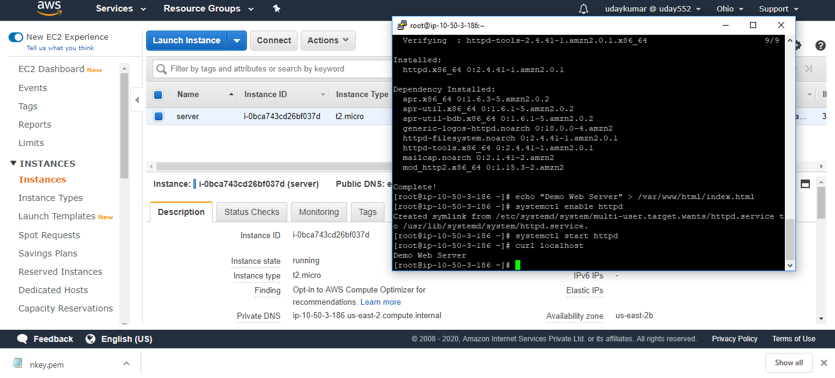

|  |
| --- |
| Generate Audit trial report of the AWS environment |
| Generate Credential report of the IAM environment |
| Create RDS instance and establish remote connectivity from any one of the ec2 instance created above steps ( once again I will try and update you this task) |
| Create cloudformation stack using the attached template |